# Report

CSS validation

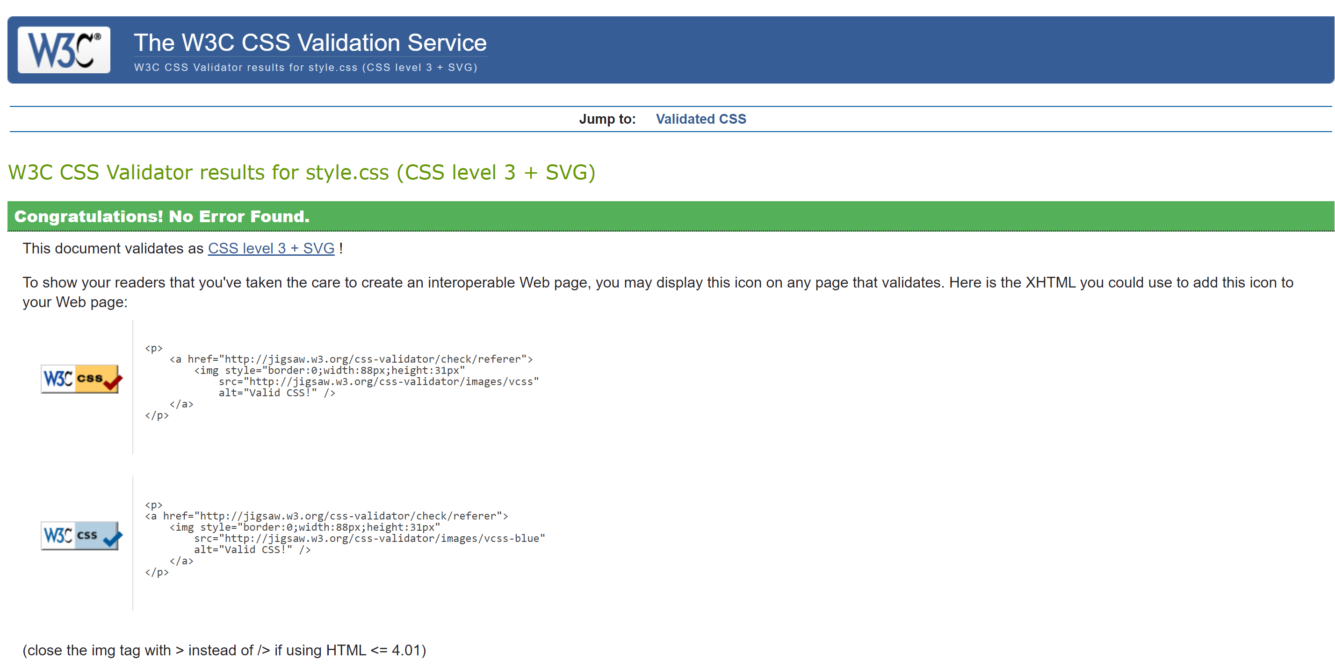

HTML Validation

Arnold Split

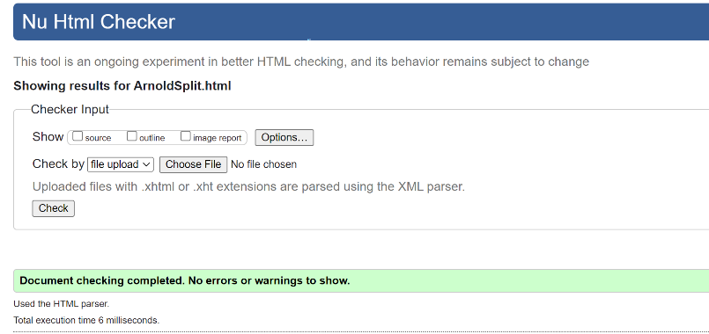

Bro Split

HomePage

Upper Lower

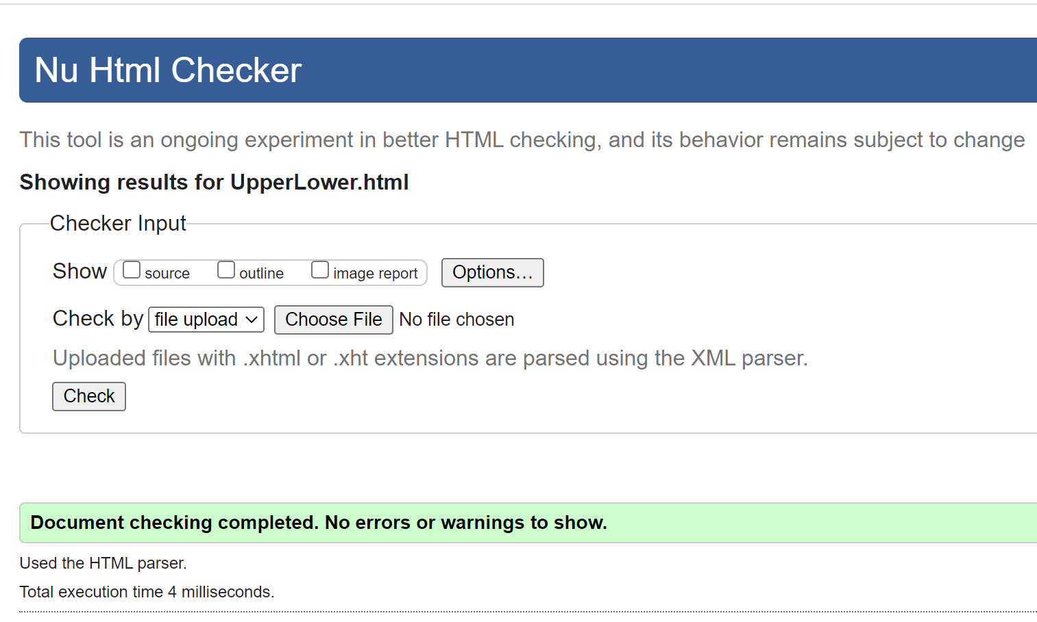

PPL

Site Map

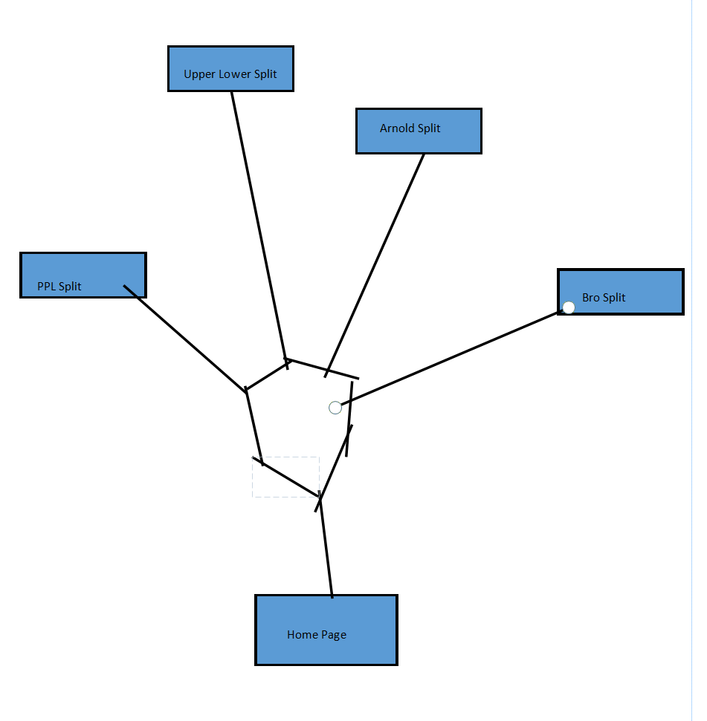

WireFrame

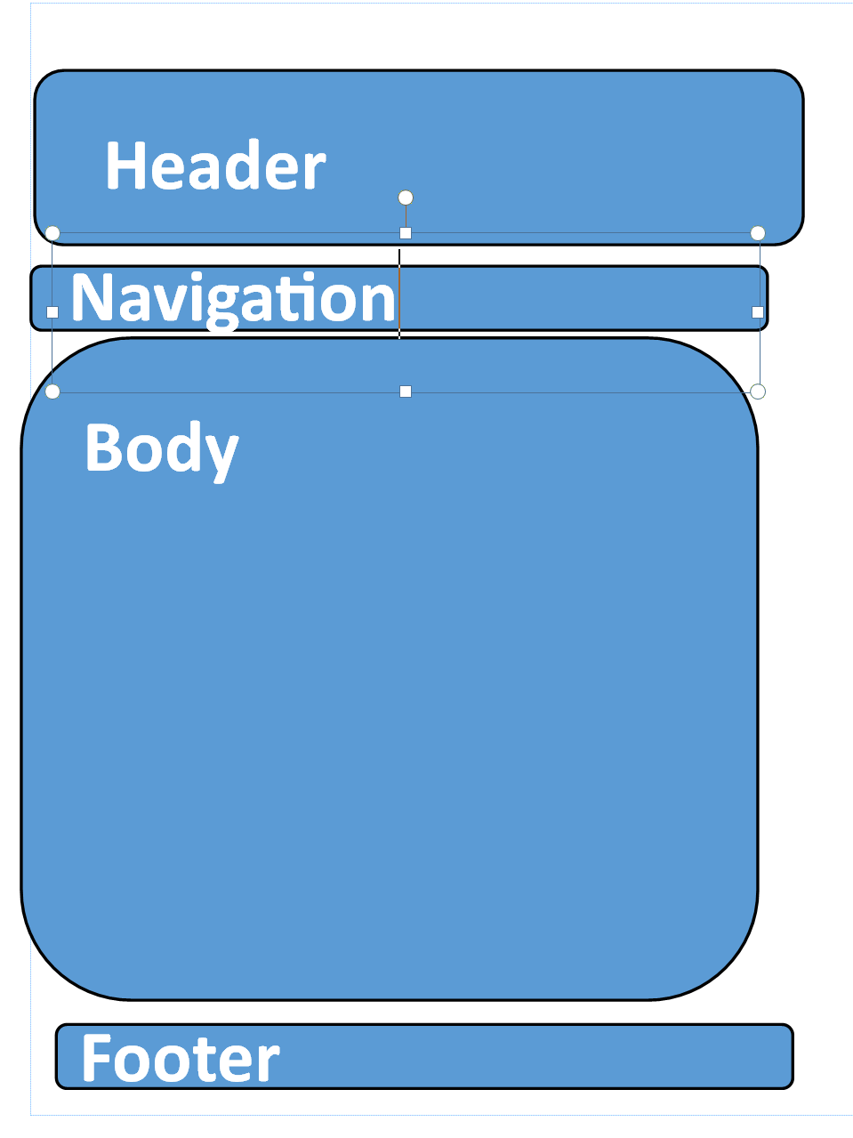

References:

(2023). Ironmanmagazine.com. <https://www.ironmanmagazine.com/wp-content/uploads/arnold-Workout.jpeg>

Laid, D. (2021). [Instagram] Available at: https://www.instagram.com/p/CdyVxBALXMB/ [Accessed 14 Feb. 2023].

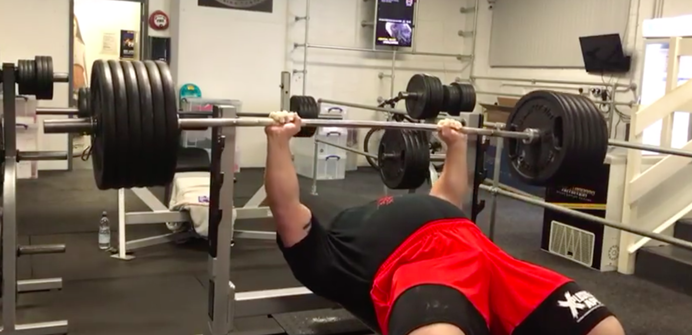

www.youtube.com. (n.d.). Eddie Hall 265kg Bench Press at Strength Asylum. [online] Available at: https://youtu.be/74nhtcP1Ur0 [Accessed 14 Feb. 2023].

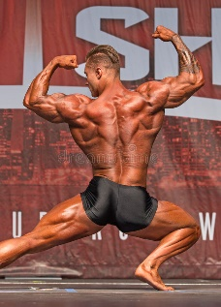

Dreamstime.com. (2023). Available at: https://thumbs.dreamstime.com/b/nova-scotia-bodybuilder-wins-toronto-bodybuilder-chris-bumstead-new-brunswick-canada-showed-off-outstanding-powerful-94143573.jpg [Accessed 14 Feb. 2023].

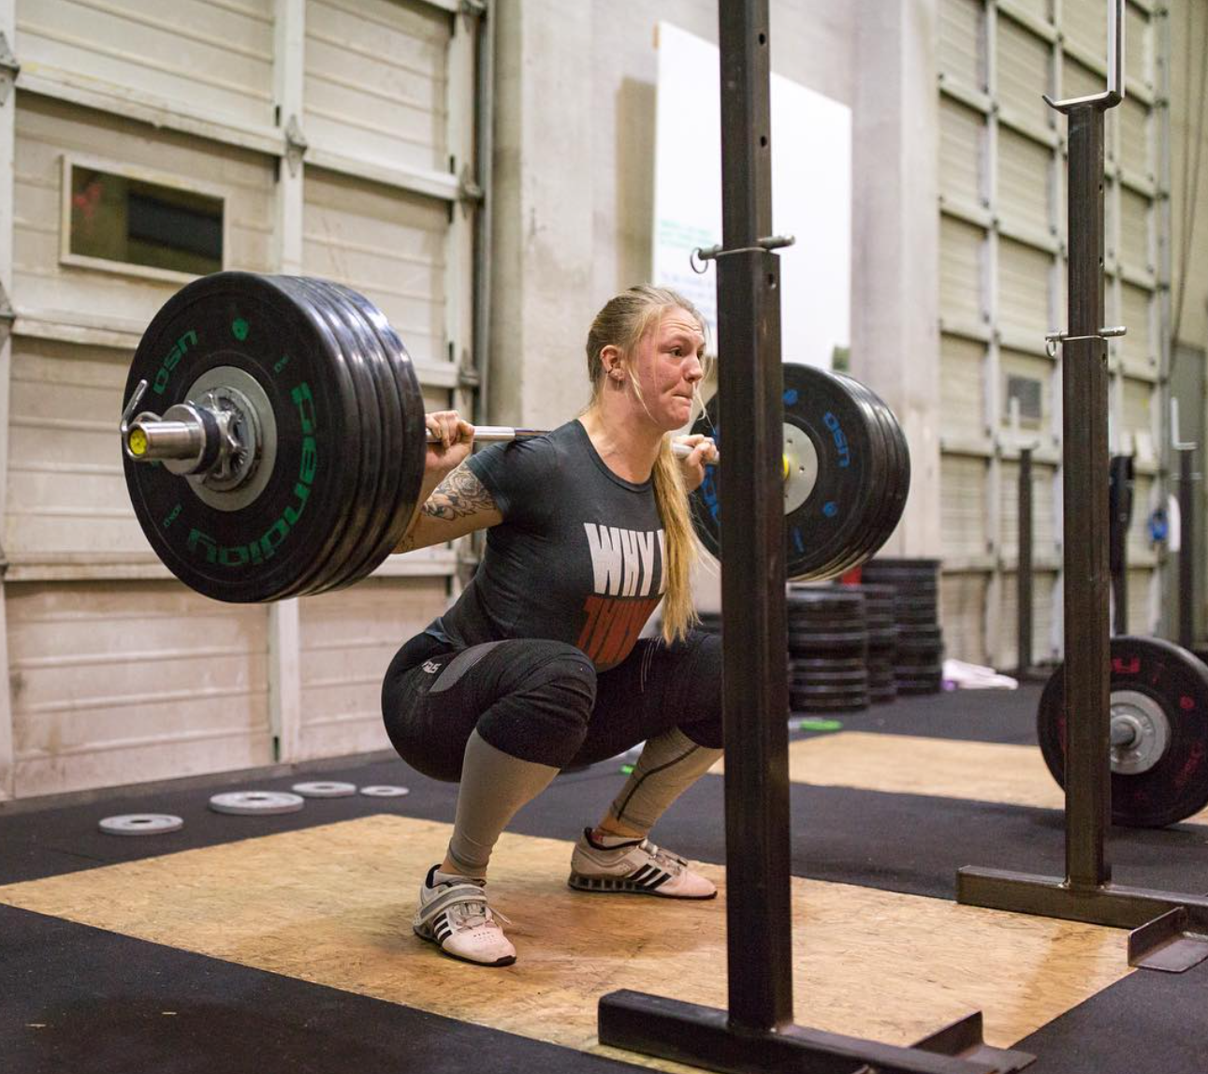

Fulcrumtraininghall. (2017, February 21). Fulcrum Training Hall. https://www.instagram.com/p/BQvRNK1FcoL/?utm_source=ig_embed&ig_rid=e3e27888-5738-4a82-ba59-98ae5f25c089